- Inversion in conditional sentences
Conditional sentences with inversion are more formal than those that follow the usual word order.

1st Conditional
In real conditionals inversion is found with the modal verb should, but it is only used in formal language.
Example:
If he remembers his own name, we’ll be able to help him.
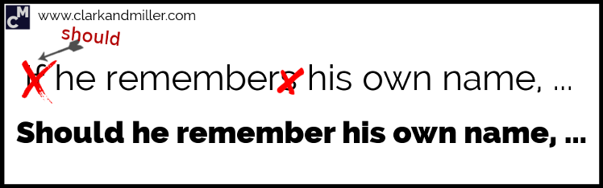
Should he remember his own name, we’ll be able to help him.

2nd Conditional
In unreal conditionals it is common to find inversions in formal language.
Example 1:
If he pushed the button, we’d all have problems.
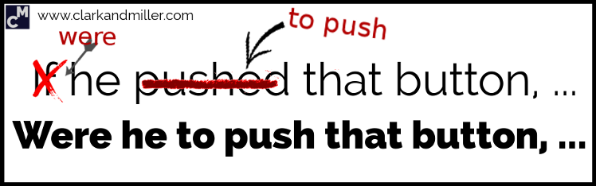
Were he to push the button, we’d all have problems.
Example 2:
If I was / were ridiculously rich, I think I’d still work.
Were I ridiculously rich, I think I’d still work.
Example 3 - NEGATIVE:
If it weren't for Miguel, we wouldn't know what to do now.
Were it not for Miguel, we wouldn't know what to do now.

3rd Conditional
Example 1:
If we had arrived sooner, we wouldn’t have missed the beginning.
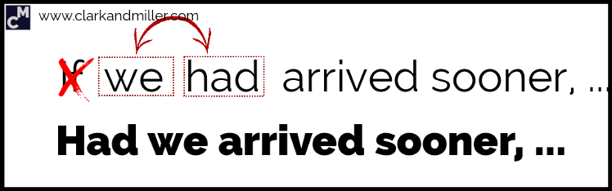
Had we arrived sooner, we wouldn’t have missed the beginning.

In negative clauses with inversion, we don't use contracted forms:

Example 2:
If the people hadn’t been informed, the situation would have been much worse.
Had the people not been informed, the situation would have been much worse.

- When We Use a Negative Adverb or Adverb Phrase at the Beginning of the Sentence

Usually, we put the expression at the beginning of the sentence to emphasize what we’re saying. It makes our sentence sound surprising or striking or unusual. It also sounds quite formal.

The inversion of the subject and the verb can take place after a clause that begins with:

hardly…when/before
rarely
never
seldom
only then
not only…. but
no sooner … than
scarcely…when/before
only later
nowhere
in no way
little
only in this way
on no condition
on no account
in/under no circumstances

Examples:

- Hardly had I closed my door when I realized I had lost the keys.
- Rarely has he got mark 10 in Math.
- Never have I met such well-behaved children before. They are as good as gold.
- Seldom do we receive any apology when mistakes are made.
- Only then did I understand the problem.
- Not only was it raining all day at the wedding but also the band was late.
- No sooner had I arrived home than the phone rang.
- Scarcely had I got off the bus when it crashed into the back of a car.
- Only later did she realize her mistake.
- Nowhere is the effect of government policy more apparent than in agriculture.
- In no way can theory be separated from practice.
- Little does she understand me.
- Only in this way can any future generations gain a balanced view of society in our time.
- On no condition should untrained personnel use the equipment.
- On no account should the house be left unlocked.
- Under no circumstances is the money to be paid.

- Inversion in the second part of the sentence

In the following expressions, the inversion comes in the second part of the sentence:

Not until Not until I saw John with my own eyes did I really believe he was safe.
Not since Not since Lucy left college had she had such a wonderful time.
Only after Only after I'd seen her flat did I understand why she wanted to live there.
Only when Only when we'd all arrived home did I feel calm.
Only by Only by working extremely hard could we afford to eat.

- We Can Use Inversion after
“So/such …that”

For emphatic reasons.

Examples:

So loud was the noise that I couldn’t work.
Such was a day that we will all remember forever.

- We can use inversion if we put an adverbial expression of place at the beginning on the sentence.

This is also quite formal or literary.

Examples:

On the table was all the money we had lost.
(Normal sentence: All the money we had lost was on the table.)

Round the corner came the knights.
(Normal sentence: The knights came round the corner.)

